CL2001 | Lab 7
Data Structures Lab | Advance Sorting
NATIONAL UNIVERSITY OF COMPUTER AND EMERGING SCIENCES
Fall 2025

Lab Content

- Quick Sort
- Merge Sort
- Radix Sort

Quick Sort
Quick Sort Algorithm is a Divide & Conquer algorithm. It divides input arrays in two partitions, calls itself for the two partitions (recursively) and performs in-place sorting while doing so. A separate partition () function is used for performing this in-place sorting at every iteration.
There are 2 Phases in the Quick Sort Algorithm.

Division Phase:
  - Divide the array into 2 halves by finding the pivot point to perform the partition of the array.
  - The in-place sorting happens in this partition process itself.

Recursion Phase:
  - Call Quick Sort on the left partition
  - Call Quick Sort on the right partition.

Quick Sort Algorithm:
  - Make the right-most index value pivot
  - Partition the array using pivot value
  - Quicksort left partition recursively
  - Quicksort right partition recursively
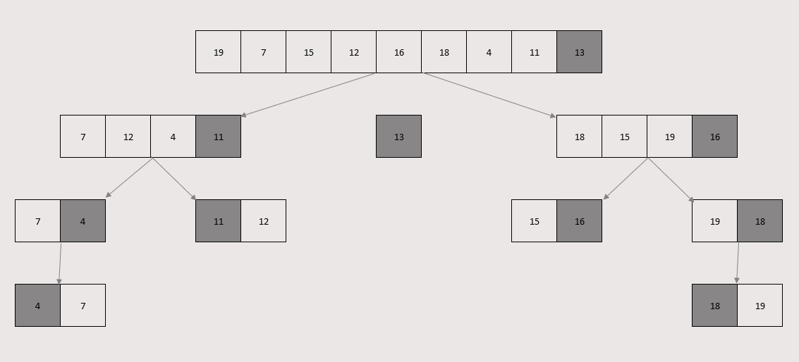

Pivot Selection:

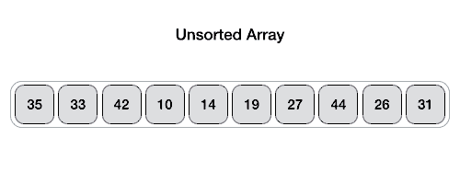

- Choose the any index value as pivot
- Take two variables to point left and right of the list excluding pivot
- Left points to the low index & Right points to the high index
- While value at left is less than pivot move right & While value at right is greater than pivot move left
- If both left & right step does not match swap left and right
- If left = right, the point where they met is new pivot

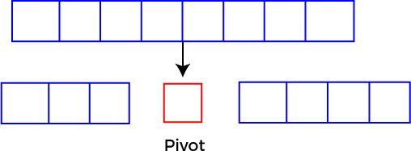

Pseudocode:
function partitionFunc(left, right, pivot)
leftPointer = left
rightPointer = right - 1
while True do
while A[++leftPointer] < pivot do
//do-nothing
end while
while rightPointer > 0 && A[--rightPointer] > pivot do
//do-nothing
end while
if leftPointer >= rightPointer
break
else
swap leftPointer,rightPointer
end if
end while
swap leftPointer,right
return left pointer
end function

Merge Sort

Merge sort is a sorting algorithm that follows the divide-and-conquer approach. It works by recursively dividing the input array into smaller subarrays and sorting those subarrays then merging them back together to obtain the sorted array. In simple word, it continuously splits the array in half until it cannot be further divided i.e., the array has only one element left (an array with one element is always sorted). Then the sorted subarrays are merged into one sorted array.

Merge sort is a popular sorting algorithm known for its efficiency and stability. It follows the divide- and-conquer approach to sort a given array of elements.
Here’s a step-by-step explanation of how merge sort works:
- Divide: Divide the list or array recursively into two halves until it can no more be divided.
- Conquer: Each subarray is sorted individually using the merge sort algorithm.
- Merge: The sorted subarrays are merged back together in sorted order. The process continues until all elements from both subarrays have been merged.
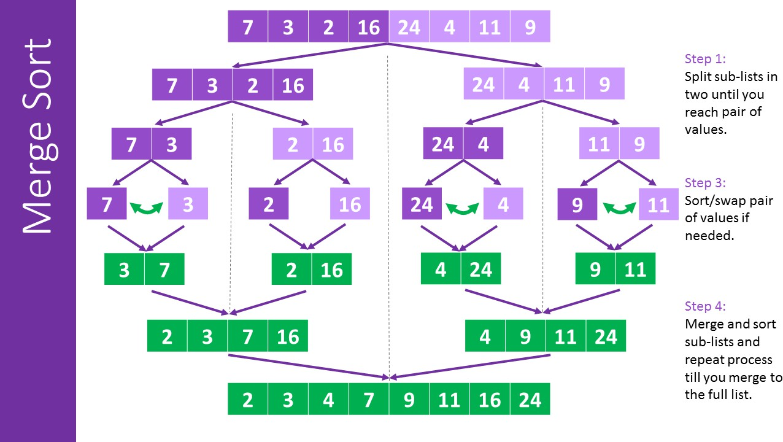

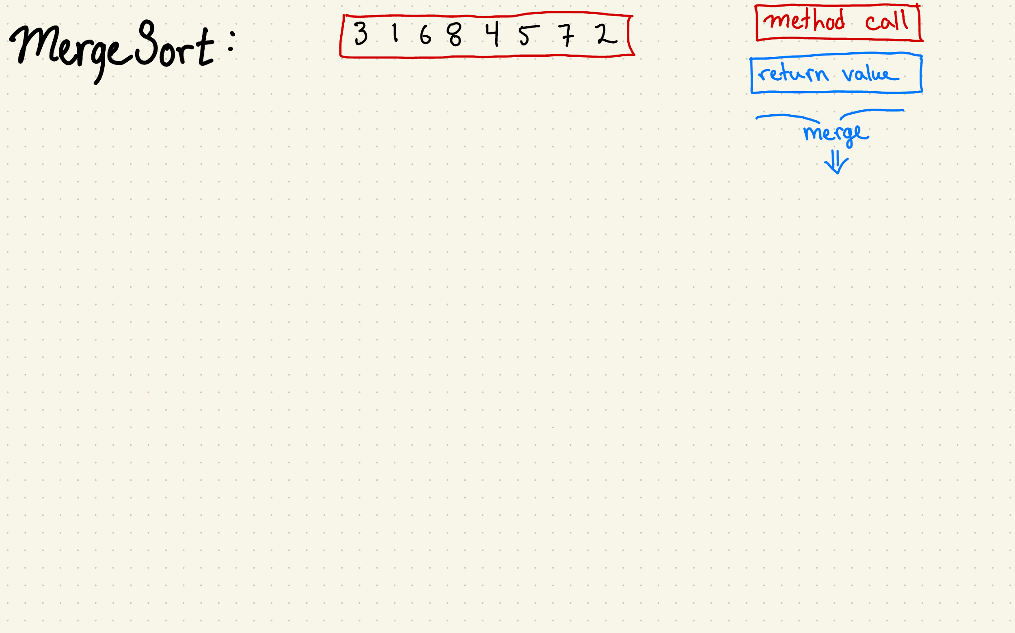

Merge Sort Algorithm:
  - Divide the list recursively into two halves until it can no more be divided.
  - Merge the smaller lists into new list in sorted order.

Pseudocode:
function mergeSort(arr, left, right) if left < right do
mid = left + (right - left) / 2 mergeSort(arr, left, mid) mergeSort(arr, mid + 1, right) merge(arr, left, mid, right)
end if end function

function merge(arr, left, mid, right) n1 = mid - left + 1
n2 = right - mid leftArr[n1], rightArr[n2]

for i = 0 to n1 - 1 do leftArr[i] = arr[left + i]
end for
for j = 0 to n2 - 1 do rightArr[j] = arr[mid + 1 + j]
end for
i = 0, j = 0, k = left while i < n1 and j < n2 do
if leftArr[i] <= rightArr[j] then
arr[k] = leftArr[i] i = i + 1
else
arr[k] = rightArr[j] j = j + 1
end if
k = k + 1 end while

while i < n1 do
arr[k] = leftArr[i] i = i + 1
k = k + 1 end while
while j < n2 do
arr[k] = rightArr[j]
j = j + 1
k = k + 1 end while
end function

Radix Sort
Radix Sort is a linear sorting algorithm that sorts elements by processing them digit by digit. It is an efficient sorting algorithm for integers or strings with fixed-size keys. It is a non-comparative sorting algorithm and avoids comparison by creating and distributing elements into buckets according to their radix. For elements with more than one significant digit, this bucketing process is repeated for each digit, while preserving the ordering of the prior step, until all digits have been considered. For this reason, radix sort has also been called bucket sort and digital sort.

Here’s a step-by-step explanation of how radix sort works:
- Take input array and find MAX number in the array
- Define 10 queues each representing a bucket for each digit from 0 to 9.
- Consider the least significant digit of each number in the list which is to be sorted.
- Insert each number into their respective queue based on the least significant digit.

- Group all the numbers from queue 0 to queue 9 in the order they have inserted into their respective queues.
- Repeat from step 3 based on the next least significant digit.
- Repeat from step 2 until all the numbers are grouped based on the most significant digit.
- https://www.youtube.com/watch?v=XiuSW_mEn7g
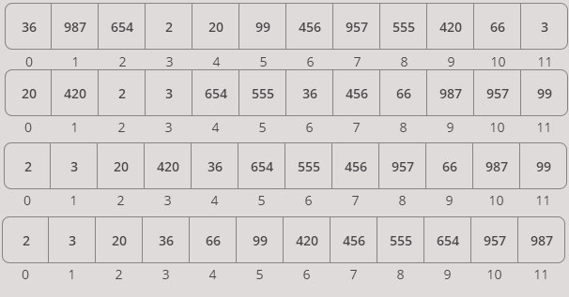
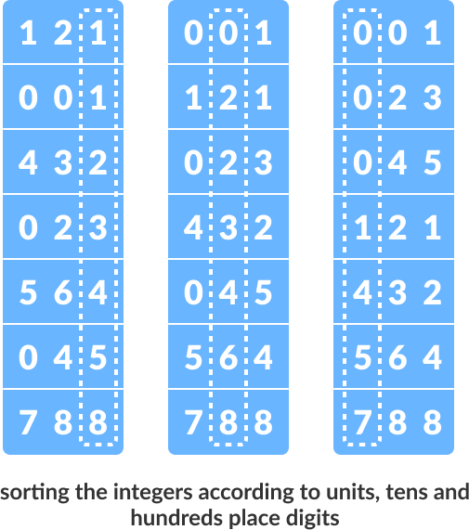
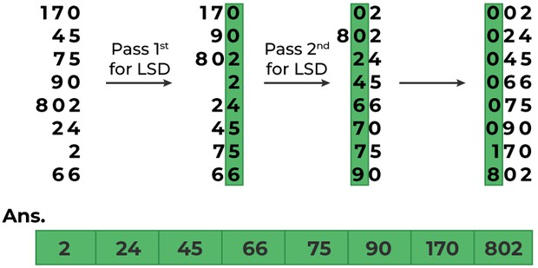

Original Array:

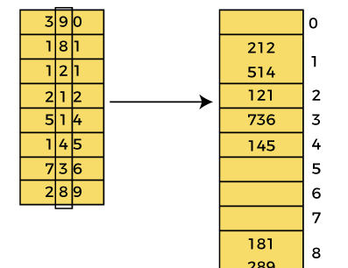
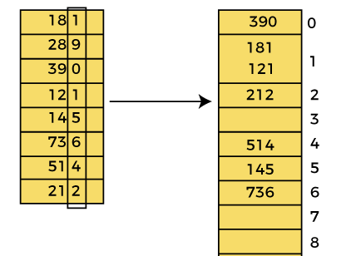
Pass 1: Pass 2:

Pass 3:
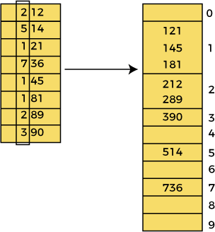

Pseudocode:

function getMax(arr, n) mx = arr[0]
for i = 1 to n - 1 do if arr[i] > mx then
mx = arr[i] end if
end for return mx
end function

function countSort(arr, n, exp) output[n]
count[10] = {0}
for i = 0 to n - 1 do count[(arr[i] / exp) % 10] += 1
end for

for i = 1 to 9 do
count[i] += count[i - 1] end for
for i = n - 1 downto 0 do
output[count[(arr[i] / exp) % 10] - 1] = arr[i] count[(arr[i] / exp) % 10] -= 1
end for
for i = 0 to n - 1 do arr[i] = output[i]
end for end function

function radixsort(arr, n) m = getMax(arr, n)
for exp = 1 to m do countSort(arr, n, exp

